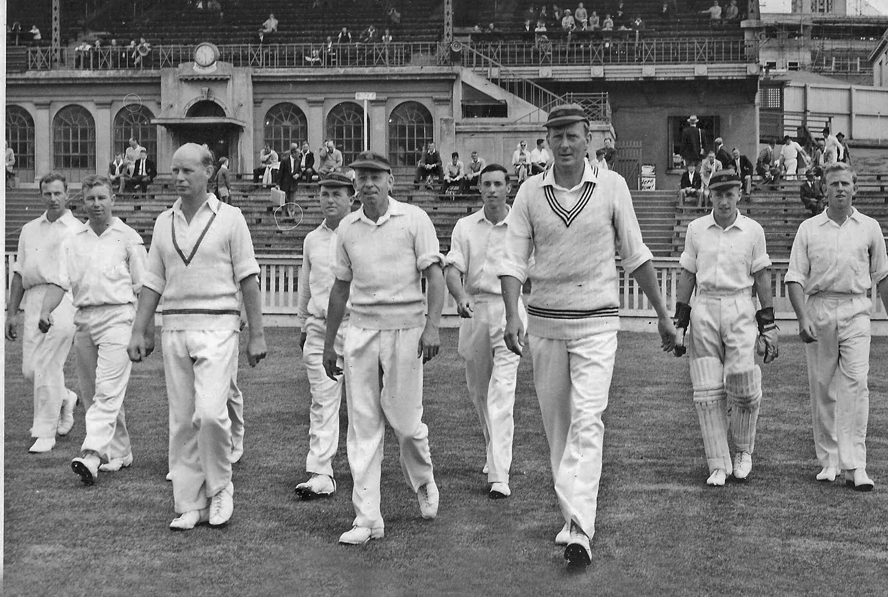

**Canterbury take the field Basin Reserve 2 January 1962.**

**From left: D Hill, DL Gallop, MB Poore, K Thomson, JW Kiddey, BG Hadlee, AR MacGibbon, JE England, PB Truscott**

**BA Bolton, JHM Dawson obscured**

**Wellington 232 and 61/1. Canterbury 81/9 dec and 211. Wellington won by nine wickets**